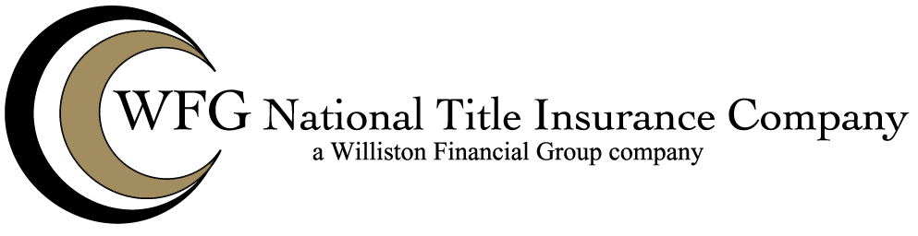

Attached to Policy No. __________
Issued By
WFG NATIONAL TITLE INSURANCE COMPANY

The Company hereby insures against any loss or damage which the insured shall sustain by reason of damage to existing improvements, including lawns, shrubbery or trees, resulting from the exercise of any right to use the surface of the land for the extraction or development of water excepted from the description of the land or shown as an exception in Schedule B.

This endorsement is issued as part of the policy. Except as it expressly states, it does not (i) modify any of the terms and provisions of the policy, (ii) modify any prior endorsements, (iii) extend the Date of Policy or (iv) increase the Amount of Insurance. To the extent a provision of the policy or a previous endorsement is inconsistent with an express provision of this endorsement, this endorsement controls. Otherwise this endorsement is subject to all of the terms and provisions of the policy and of any prior endorsements.

WFG NATIONAL TITLE INSURANCE COMPANY

By: ______________________________
Authorized Signatory

